**Department of Electronics and Communication Central University of Rajasthan, Ajmer**



Signal and System Lab

Subject ...................................................................................................

ECE 214

Subject Code ...................................................................................................

8

111

Experiment No. .....................................................................................

Date:- - -2024

Roll no:- 2022BTECE012

Name:- Ojasvee Satija

**Title: -** Write a MATLAB code to convolute two discrete time sequences. Plot all the sequences and verify the result by analytical calculation.

**Apparatus required:** - Downloaded MATLAB or OCTAVE software in device.

**Introduction:**- For discrete time sequences the convolution is given as

$$y\left(n\right)=\sum_{k=-∞}^{∞}{x\left(k\right)h(n-k)}$$

The above expression for discrete output signal y(n)is called the convolution sum of discrete time input signal x(n) and discrete time unit impulse response that is;

**Code:-**

**output:-**

**Verification;-**

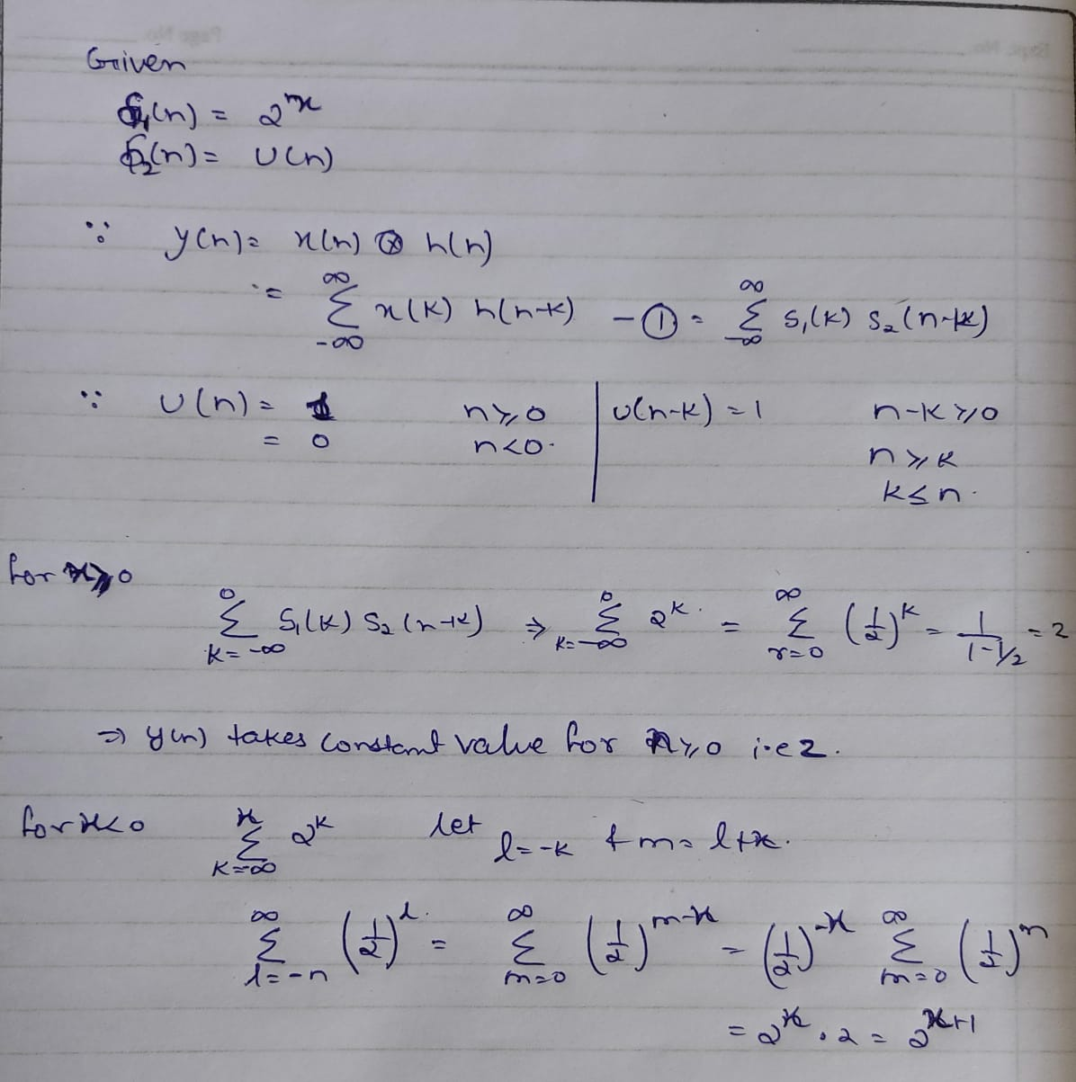

**Result:-** Performed the convolution on two discrete time sequences and plotted the results.